**Fundamental Of Programming Language**

1) Basic Concepts of Programming Languages?

- Syntax

- Data Structures

- Variables

- Operators

- Control & Looping Structures

- Functions

- Array & Strings

- File Handling

2) Syntax of Programming Languages?

- Syntax refers to the rules that define the structure of a language. Syntax in computer programming means the rules that control the structure of the symbols, punctuation, and words of a programming language.

- Without syntax, the meaning or semantics of a language is nearly impossible to understand.

- **Compilers** convert programming languages **like Java or C++** into binary code that computers can understand. If the syntax is incorrect, the code will not compile.

- **Interpreters** execute programming languages such as JavaScript or Python at runtime. The incorrect syntax will cause the code to fail.

3) What Is Tokens?

- C program consists of various tokens

Ex: Keyword, Identifier, Constant, String Literal, Operators, or a Symbol.

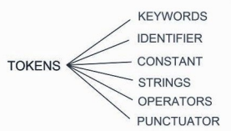

- **Identifiers:**

- Identifier is a name used to identify avariable, function, or any other user-defined item.

- Ex. - num1, getchar (), sum, ab_c etc.

- Rules for writing the names of identifies:

- An identifier starts with a letter A to Z, a to z,

- Or an underscore '_'. Followed by zero or more letters, underscores, and digits (0 to 9).

- **Keywords:**

**-** Some Reserved keywords names given in the next slide cannot be used as identifier.

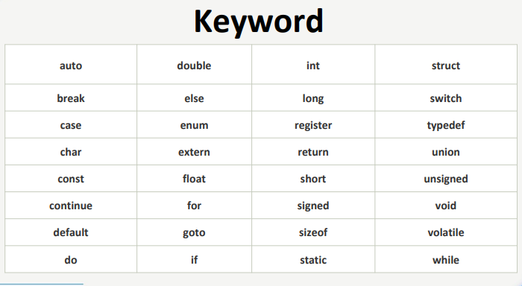

- **Strings:**

**-** Strings in C are always represented as a set of characters having null character '\at the end of the string.

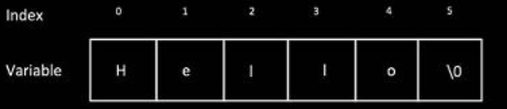

**- Operators:**

- An operator is a symbol that tells the compiler to perform specific mathematical or logical functions.

- Ex. - +, -, *, /, ==, ++, --, etc.

-**Special Characters:**

**-** Various Punctuators are used as a part of Syntax.

- Ex: - [ ], ( ), { }, #, * etc.



**- Constants:**

- A constant is a value assigned to variable which will remain the same throughout the program.

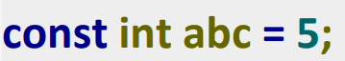

4) What Is Data Structures?

- A data structure is a particular way of organizing data in a computer so that it can be used effectively.

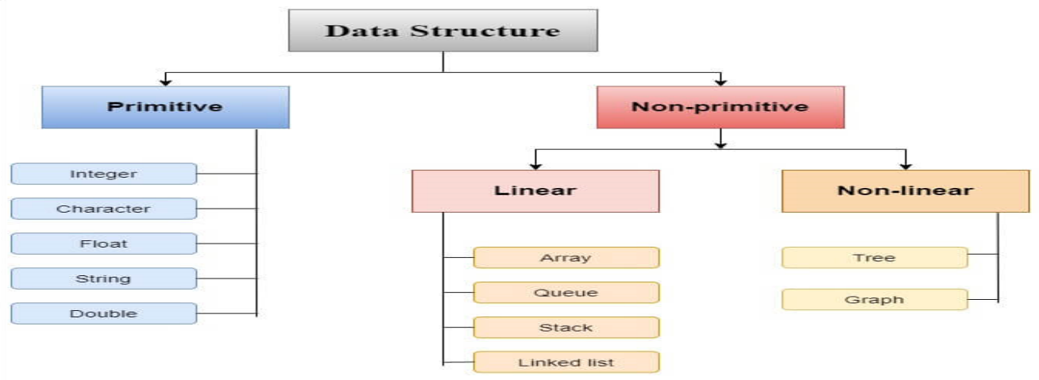

5) What Are Data Types?

- A data type specifies what type of data a variable can store such as integer, floating, character, etc.

- Ex. - int, float, char etc.